Retail Businss Performance & Profitability Analysis

Introduction
This project focuses on analyzing retail transaction data to identify profit-draining product categories, optimize inventory turnover, and study seasonal behaviour of different products. The analysis helps derive strategic business recommendations using a combination of SQL, Python, and PowerBi.

Abstract
We used the Superstore retail data set, cleaned and imported it into SQL to perform key aggregations. Using SQL, we calculated profit margins across categories and sub-categories. In Python, we analyzed the relationship between inventory days and profit margin and found a weak correlation (~0.0047), suggesting inventory time doesn't heavily impact profitability. PowerBi was used to create an interactive dashboard with filters for Region, Category (Product Type), and Season, helping visualize key trends and outliers.

Tools Used
- SQL (SQLite / MySQL) for data querying
- Python (Pandas, Seaborn, Matplotlib) for data analysis and visualization
- PowerBi for interactive dashboards

Steps Involved
- Cleaned data in Python and ensured no nulls before SQL import
- Used SQL to calculate:
- Profit Margins by Category and Sub-Category
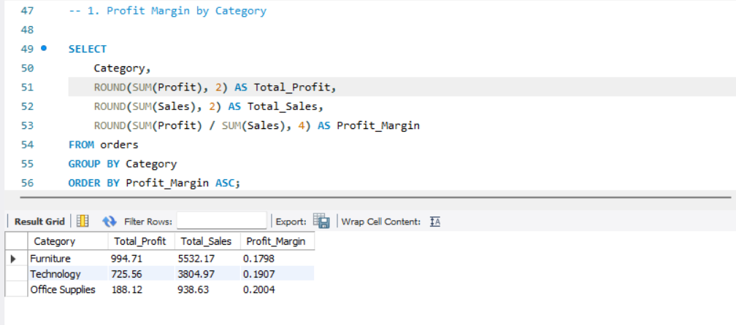

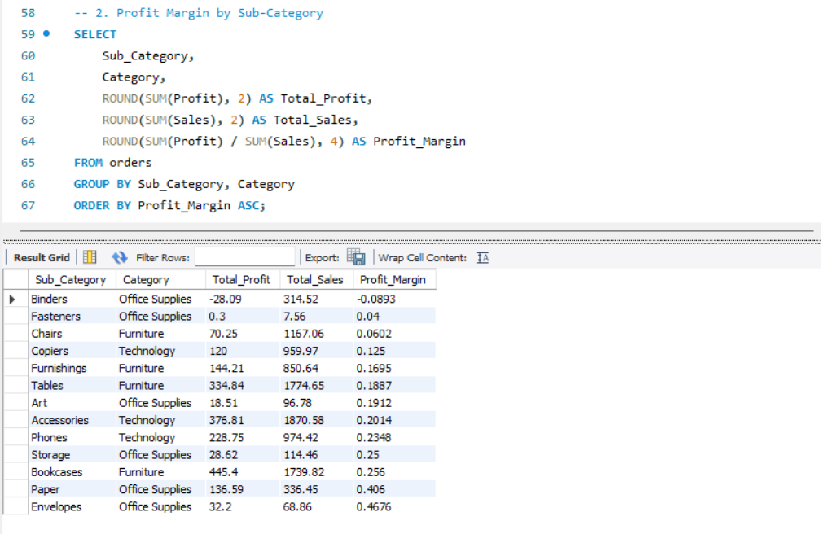
- Top Loss-Making and Profit-Making Products
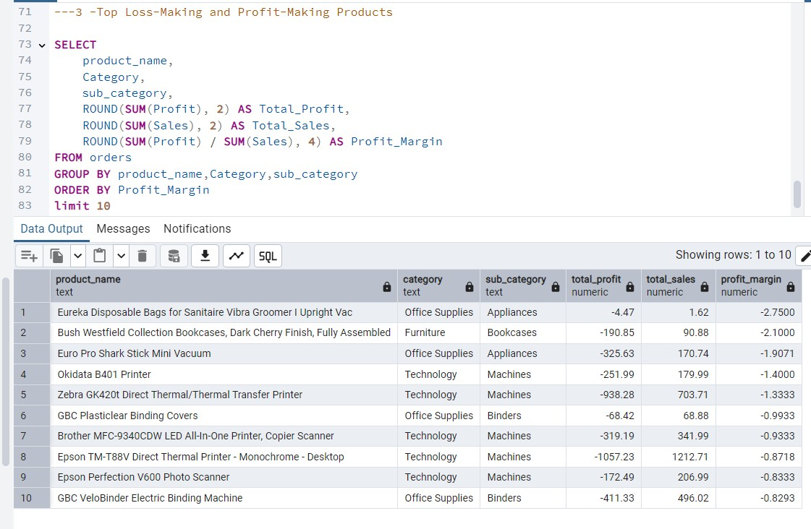
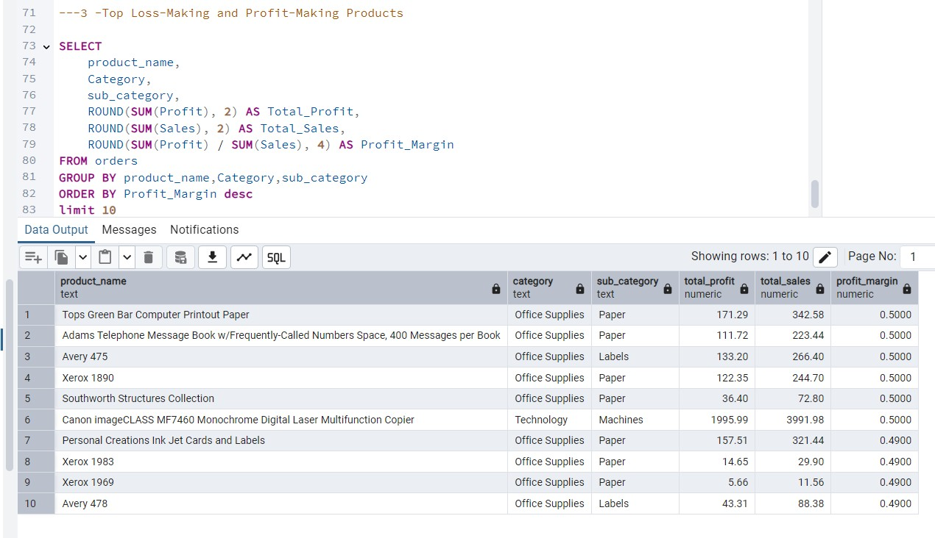
-
-
- Created calculated columns for 'Profit Margin' and 'Inventory Days'
- Analyzed correlation between Inventory Days and Profitability in Python

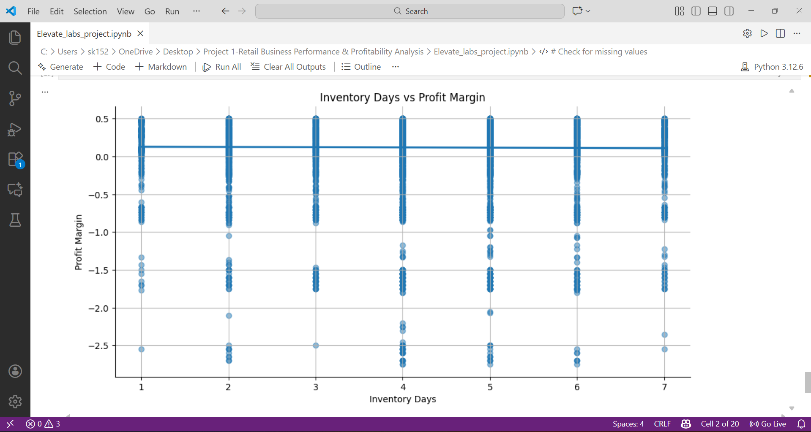
- Built PowerBi dashboard with:
  - Region, Category, and Season filters
  - Sub-Category profitability charts
  - Inventory vs Profit scatter plot with trendline
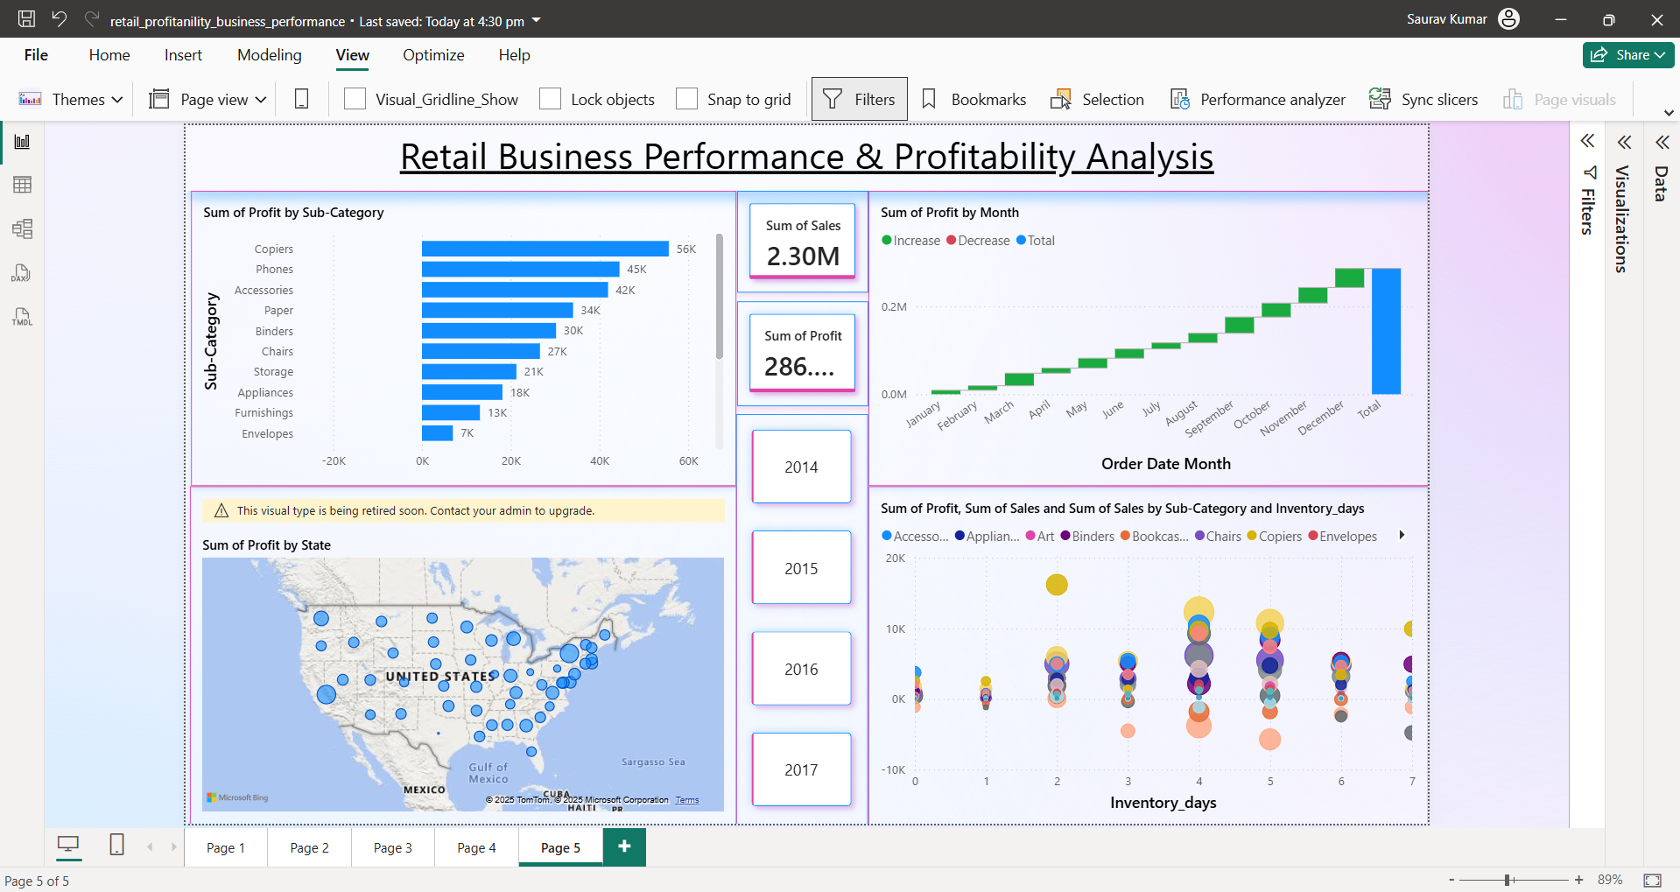
Conclusion & Insights

This analysis provided a comprehensive view of retail business performance by uncovering product categories that drain profits, examining inventory efficiency, and identifying seasonal demand patterns. The insights gained offer strategic directions for improving profitability and operational decision-making.
Key Takeaways:

- Unprofitable Categories Identified
Sub-categories such as Tables, Bookcases, and Binders demonstrated consistent losses across regions.
These categories should be re-evaluated in terms of pricing, supplier agreements, or promotional strategies.

- Overstocked & Slow-Moving Items
Products with high inventory days and low profit margins were flagged as potential overstock risks. Though the overall correlation between inventory days and profitability was weak (~0.0047), product-level analysis highlighted clear inefficiencies.

- Seasonal Trends Drive Sales
Technology and Office Supplies performed strongly in Q4 and Spring, suggesting that seasonal promotions and stock planning can be optimized to align with these patterns.

- Regional Focus is Crucial
The South and Central regions repeatedly showed negative profit margins in several categories. This indicates a need for region-specific sales strategies or inventory optimization.

- Discounting Strategy Needs Refinement
A trend was observed where higher discounts correlated with reduced profitability.
Instead of blanket discounts, targeted campaigns using past data and customer segmentation would yield better ROI.

Strategic Recommendations:
- Prioritize high-margin products in marketing and promotions.
- Reduce stock of consistently loss-making SKUs or replace them with better-performing alternatives.
- Monitor inventory turnover alongside profitability metrics to identify operational bottlenecks.
- Implement regional and seasonal pricing strategies using insights from historical data.

Key insights include identifying Tables, Bookcases, and Binders as loss-making sub-categories. South and
Central regions consistently underperformed in profitability. Products with high Inventory Days and low Profit Margin were flagged as overstocked and slow-moving. Recommendations include optimizing discounts, running targeted seasonal promotions, and reviewing inventory strategies for underperforming regions.

6

